Here is a simple step-by-step Python project that you can list on your portfolio as a college student:

Project Title: Guess the Number Game

Description: In this project, you will create a simple Python program that generates a random number between 1 and 100 and asks the user to guess the number. The program will provide feedback to the user whether the guess is too high or too low until the user guesses the correct number.

Step 1: Import the random module

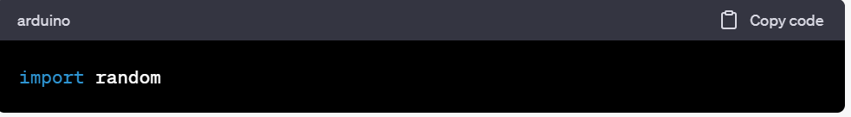

Step 2: Generate a random number between 1 and 100

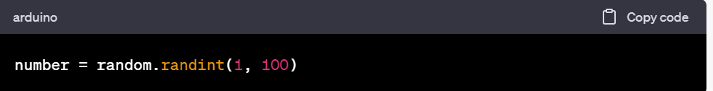

Step 3: Ask the user to guess the number and store their guess in a variable

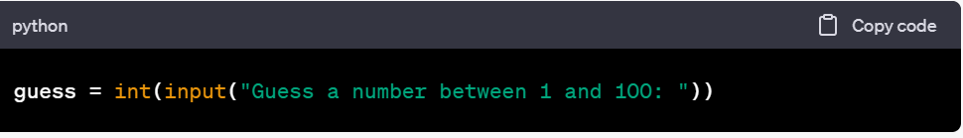

Step 4: Create a while loop that will continue to ask the user to guess the number until they guess correctly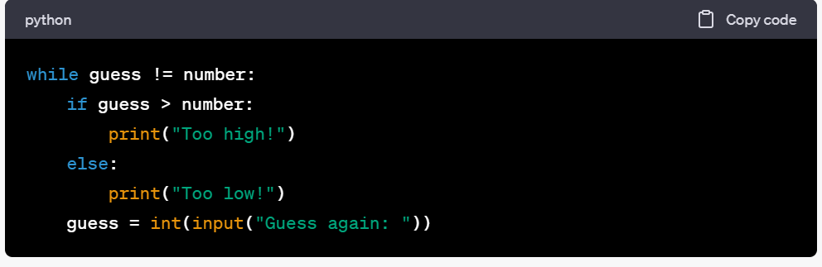

Step 5: Add a message to inform the user when they guess the correct number

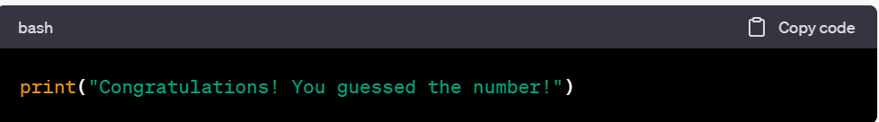

Step 6: Add an option for the user to play again

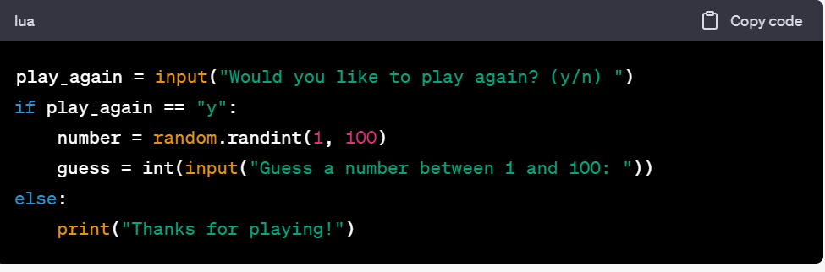

Once you have completed the project, you can add it to your portfolio by creating a GitHub repository for the project and linking to it on your portfolio website. You can also add screenshots or a video of the program in action to showcase your programming skills. Good luck with your portfolio!